The research paper aims to find if cows face high levels of stress before being slaughtered. One measure of stress was the level of heart rate for a cow. If cows undergo stress, then their corresponding heart rate levels will change and most likely increase as they move from one phase to the next one closer to being slaughtered. Heart rates were measured at four different phases. The first phase was when the cows faced first contact with pen mates. The second phase was when the cows were isolated from pen mates for prepping. The third phase was when the cows restored visual contact with the pen mates. Finally, the fourth stage was when the cows made first contact with human prior to being slaughtered. Eight cows were selected, and their heart rates were measured for each stage.

This research conveys an underlying experiment which considers finding differences in the means of heart rates across the aforementioned four different phases. An analysis of variance (ANOVA) is the recommended choice for this case. Since there are different types of ANOVA, we have examined what would probably align with the data and requirements. In this case it was a Randomized Block Design where the cows are considered blocks and the phase is the factor. It also is a balanced design since the number of observations are equal when grouped by treatment and block.

ANOVA has two important assumptions which are normality and homoscedasticity on the dependent variable. The following image to the left shows a histogram for the dependent variable HRATE which roughly follows a normal distribution. We can accept this distribution as close to normal because there is robustness for the normality assumption. The image on the right shows the distributions of heart rates by phase which was an output produced when conducting Bartlett’s test of homoscedasticity. Although there are differences in standard deviations among the four groups, having a balanced design will give some flexibility for this assumption and we will not be required to do a variance-stabilizing transformation on Heart Rate.

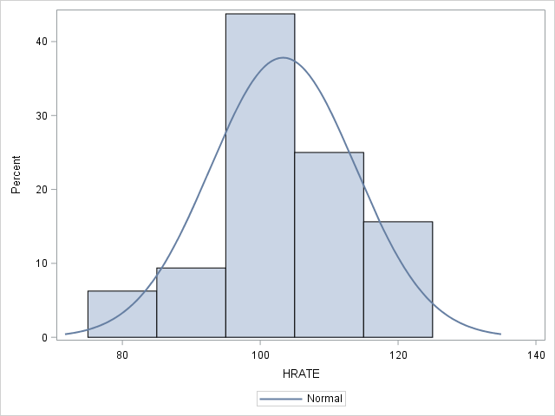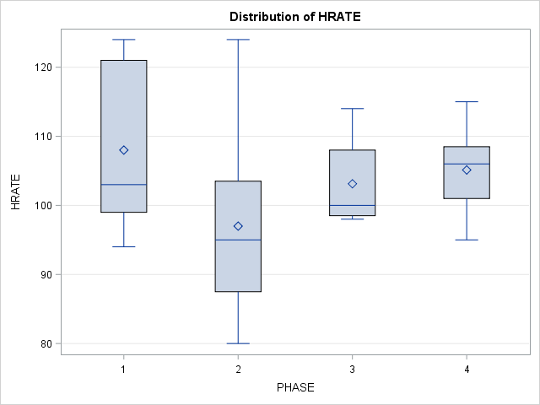

The following graphs show the actual data points of the cows and their heart rates by each phase. As we can see from the graphs, heart rates do not appear to have a constant linear trend as the cow proceeds to the next phase. However, it seems that there are differences in heart rates, but they differ by cow. This is just a preliminary screening of what we would expect in the actual ANOVA analysis.

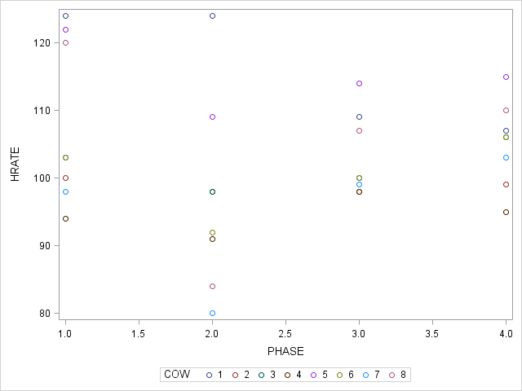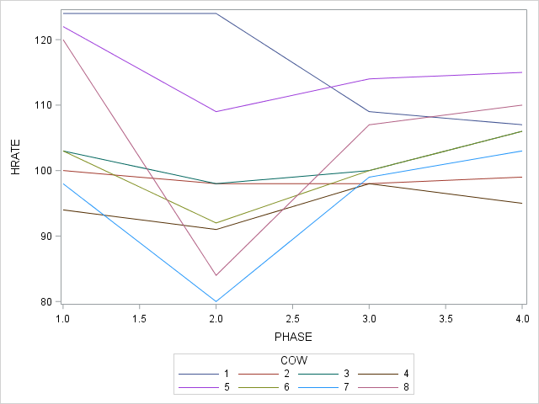

The following tables below show the ANOVA results of the underlying model of HRATE = PHASE COW. The Null Hypothesis is:

For each block (cow), H0: μphase1 = μphase2 = μphase3 = μphase4

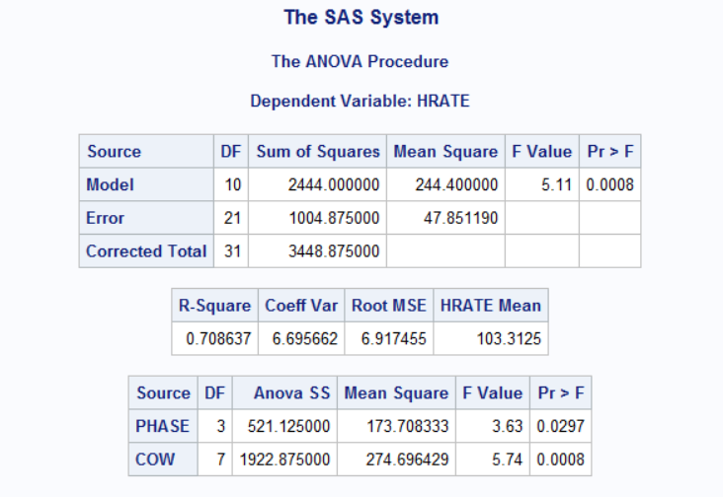

The F score for the model has a p-value of 0.0008 which is significant. This means that there is statistical utility for the underlying regression model and there are significant differences in means for heart rates among phases when blocking by cow number. When running a Tukey’s distance method, we were able to spot the groups that have different means. The following tables show the groups where significant differences were found:

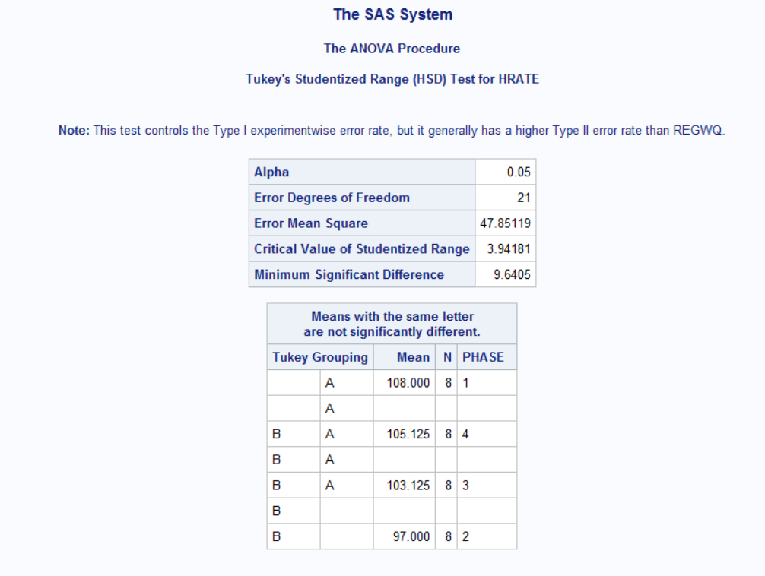

The method was able to conclude that phase 2 is not grouped with phases 1,4, and 3. Also phase 1 is not grouped with phases 2,4, and 3. This means that phases 1 and 2 definitely have statistically significant different means as the heart rate means go down. Then later when the cows restore contact with pen mates the means increase and become similar to phase 1. As for the stress research question, it would require more information to conclude whether the cows were stressed or not. We would recommend having additional variables such as the breed and age of the cow.